
Welcome to this edition of Communication Department News! We’d like to update our alumni on happenings in our department. (If you wish to unsubscribe, please reply to this email.)
Here’s what’s happening on campus:
- Back to School – Buffalo State’s fall 2022 classes began Aug. 29. Most courses (approximately 80 percent) are in-person, including those in COM, except for our online M.S. in Public Relations program and a handful of undergraduate courses. No face masks are required on campus. Students who live on campus or come to campus for classes or activities are required to have their primary COVID vaccination series, and all students and employees are strongly encouraged to stay up to date with their booster shots.

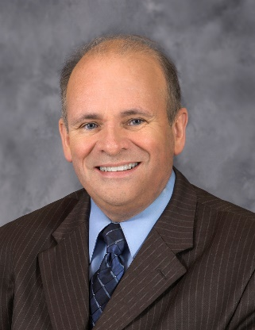
- Professor Brian Meyer To Receive SUNY Chancellor’s Award – Congratulations to Brian Meyer as a 2022 recipient of a SUNY Chancellor’s Award for Excellence in Adjunct Teaching! Brian, our longest-serving adjunct professor, joined us in fall 1994. A longtime print and broadcast journalist, he teaches COM 100 Media Literacy, SPC 205 Intro to Oral Communication, COM 210 Intro to Media Writing, and COM 303 Writing for Print and Online Journalism for us on a regular basis. He also has taught COM 325 Feature Writing and COM 304 Broadcast Writing. He also served for several years as our adjunct liaison, advising other adjuncts on pedagogical techniques.

He began his journalism career at WBEN Radio (1982-1997) as a street reporter and then managing editor, then moved to The Buffalo News (1997-2014 and 2018-present) as a reporter, digital media producer, moderator of political debates and panel discussions, and curator/editor of the digital daily newsletter Good Morning Buffalo. In 2014, he was named news director of WBFO-FM. During his tenure there, WBFO received the Associated Press Best Radio News Operation in New York State Award in 2015, 2016, and 2017. He also has won more than a dozen Associated Press awards as a reporter. Brian will be honored at Buffalo State's Faculty and Staff Recognition Ceremony on Thursday, Oct. 13 at 12:15 p.m. in the Performing Arts Center in Rockwell Hall.

- Professor Tammy McGovern Selected as SUNY PRODiG Fellow – Longtime adjunct professor Tammy McGovern joined us this fall on a full-time basis as Buffalo State’s SUNY PRODiG Fellow! The SUNY PRODiG program is designed to increase faculty diversity at SUNY schools and supports early career faculty with a two-year full-time contract, a research stipend, and professional development opportunities.
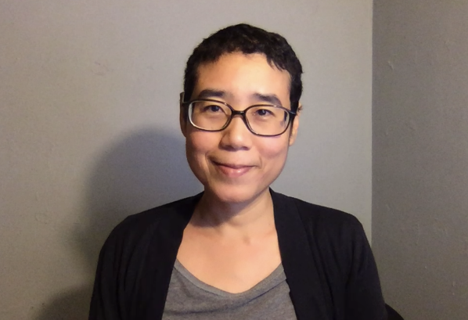
Tammy teaches COM 322 Communication Graphics, COM 336 Web and Social Media Production, and COM 312 Basic Media Production for us, and we’re thrilled to have her with us in her new role!

- SUNY Chancellor’s Award for Student Excellence – Joana Leamon, who graduated in May with a B.A. in Media Production, received the SUNY Chancellor’s Award for Student Excellence this spring!
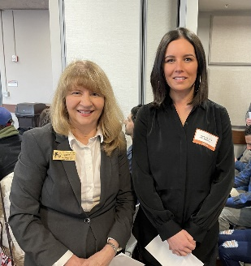
An accomplished videographer and editor, Joana took a leading role at campus radio station WBNY-FM and BSC-TV after the pandemic, received the Buffalo Broadcasters Association’s 2021 Tim Russert Media Career Award, and did an internship this spring at Buffalo Toronto Public Media, the local PBS station, which hired her after graduation. She’s shown here (at right) with me at the spring 2022 School of Arts & Sciences awards program.

- Journalism Grad Named as Buffalo News Executive Editor – Congratulations to Sheila Rayam ’90 as the new executive editor of The Buffalo News! Sheila is the first Black journalist and the second woman to hold the position in The Buffalo News’ 142-year history.
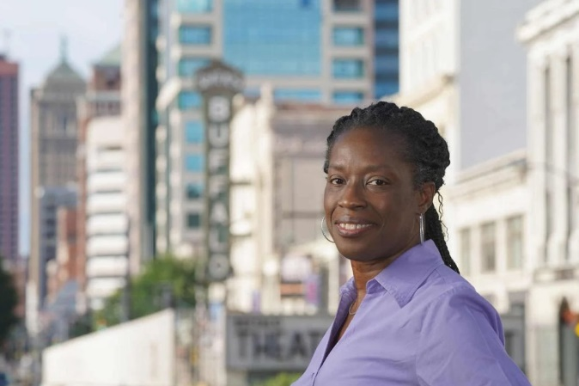
Previously, she was executive editor of Gannett’s Mohawk Valley news operations, including the Utica Observer-Dispatch, since April 2021. Before that, the Rochester native spent three decades rising through the ranks at the Democrat & Chronicle after graduating from Buffalo State. She started her new role at The Buffalo News on Aug. 22.

- Community Engagement Awards – COM faculty and students won several awards this spring from Buffalo State’s Civic and Community Engagement Office! Winners included Professor Therese Fuerst, Early Career Faculty Award for Community Engagement; Professor Annemarie Franczyk and her COM 405 Class, Outstanding Service-Learning Course Award; SPC 307 student Elaina James, Outstanding Service-Learning Student Award; and COM 433 students Joana Leamon, Steven Clare, and Tyler Nagy, Outstanding Service-Learning Group Award.

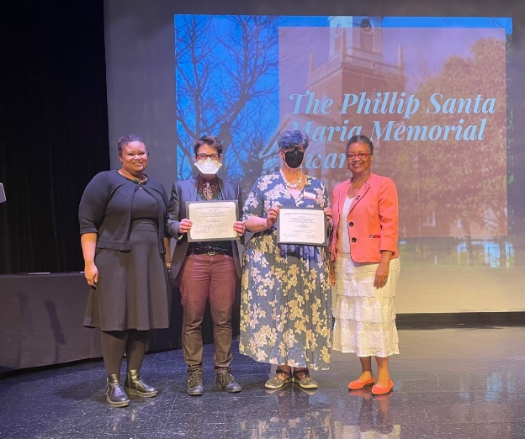
- “Beyond Boundaries” Film Series Is Recognized – Our “Beyond Boundaries” film series, which is starting its 9th year this fall, won the President’s Council on Equity and Campus Diversity Special Program Award in May at Buffalo State’s Student Leadership & Humanitarian Awards Ceremony.

Congratulations to Professors Meg Knowles and Ruth Goldman, curators of the film series!

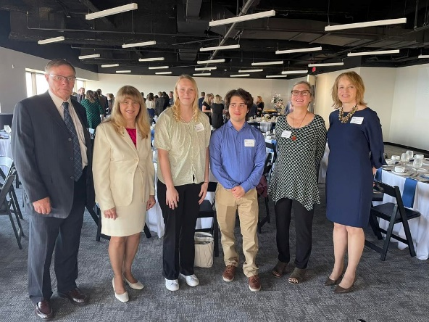
- PR and Media Production Students Win Awards – Two graduate PR students and students in two Media Production classes took home Student Excalibur Awards in June from the Public Relations Society of America’s Buffalo Niagara chapter! Congratulations to William Reuter and Katelyn Brickhouse, M.S. in PR students who won gold and silver awards, respectively, for their PR campaigns for the Boys & Girls Club of The Capital Region (Reuter) and Stitch Buffalo (Brickhouse). Students in Professor Rick Karnath’s COM 329 and Professor Dorothea Braemer’s COM 432 classes won a bronze Excalibur Award for a series of promotional videos for COM that featured outstanding students in each of our five majors.

- “Broadcasting Buffalo” Back on the Air – Our news and public affairs TV series, “Broadcasting Buffalo,” is gearing up for its third season next spring! The TV series is a partnership between the Communication Department and the Buffalo Broadcasters Association. Students in Professor Ellen Notarius’s COM 337 Electronic News Producing class collaborate with Professor Rick Karnath’s COM 429 Advanced Multi-Camera Studio Production course on the shows, which are taped weekly. The episodes air on WNYO-TV on Saturdays at 6:30 p.m. during the spring semester.
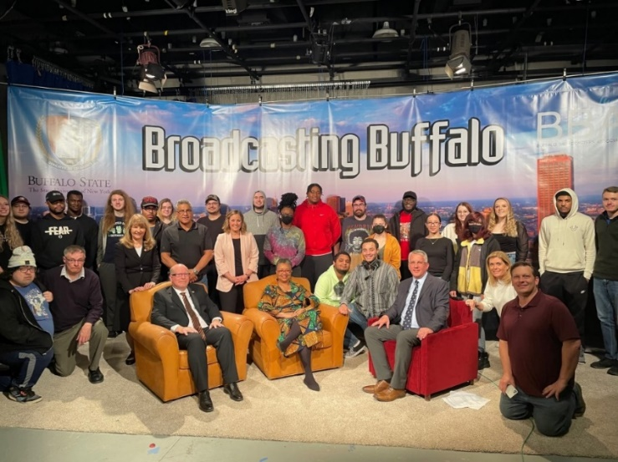

You can read details here: https://suny.buffalostate.edu/news/partnership-broadcasters-association-gives-students-unique-opportunities

- SUNY Honorary Doctorates – Congratulations to COM alumni Darryl Dennard ’81 (Broadcasting) and Eric Greenberg ’78 (Journalism), who received SUNY honorary doctor of humane letters degrees at our May 2022 commencement ceremonies! Darryl is an award-winning broadcast journalist in Chicago who launched his broadcasting career at WGRZ-TV in Buffalo, while Eric is employed at the Simon Wiesenthal Center in New York City as director of United Nations Relations and Strategic Partnerships.
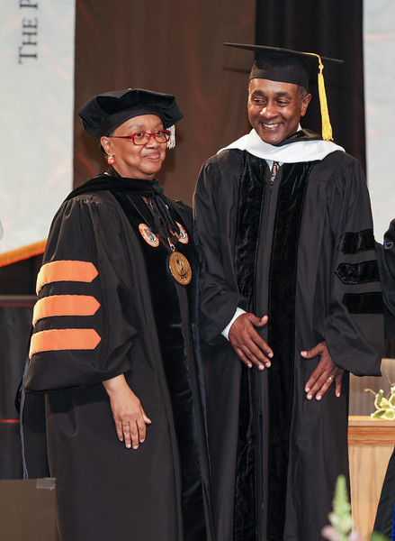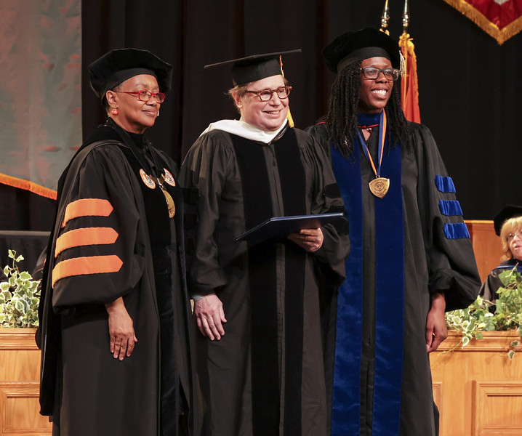
At left: Darryl Dennard with President Katherine Conway-Turner; at right: Eric Greenberg (center) with President Conway-Turner and Associate Provost Amitra Wall.


- Ronald D. Smith Memorial Scholarship – The Communication Department wishes to honor the late Professor Ron Smith, former Communication Department chair and Public Communication (PR/Advertising) faculty member, with a scholarship in his memory. The scholarship, to be awarded annually each spring, will be given to a Buffalo State Communication undergraduate student planning a career in public relations, with preference given to students in the B.A. in Public Relations and Advertising degree program. Applicants must have a GPA of 3.5 or higher, demonstrate financial need, and possess excellent writing skills, as evidenced by the submission of an essay of 500 words on the importance of strategic planning in public relations.

You can donate here: https://www.justgiving.com/campaign/buffalostate-ronsmith.

- How Did Your Buffalo State Education Impact Your Communication Career? – Let us know! Send a recent head & shoulder shot with your name, your thoughts about your Buffalo State communication education (mention your favorite COM professors too!), and a paragraph about your communication career! We plan to do periodic features about alumni on our newly revived CommBLOG. And if your company has internships or entry-level job opportunities, or you’d like to speak to a COM class, let us know! Simply reply to this email.
Looking forward to hearing from you!

Dr. Deborah Silverman, Communication Department Chair

