
Welcome to the Fall 2024 edition of Communication Department News! We’d like to update our alumni on happenings in our department. (If you wish to unsubscribe, please reply to this email.) Here’s the latest news:
- Alumni Reunions – This fall, I had the pleasure of meeting with COM alumni at Buffalo State reunions in three cities: Washington, DC (Sept. 25 at Buffalo Nite in DC, an event for ex-Buffalo residents), Southern California (Oct. 15 in Long Beach) and New York City (Nov. 12).

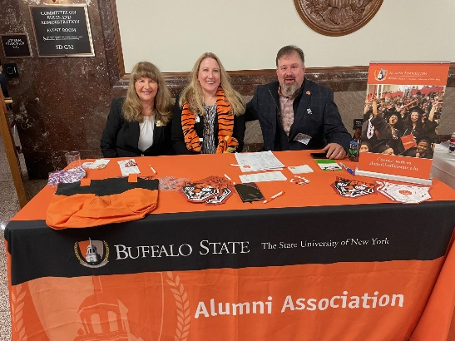
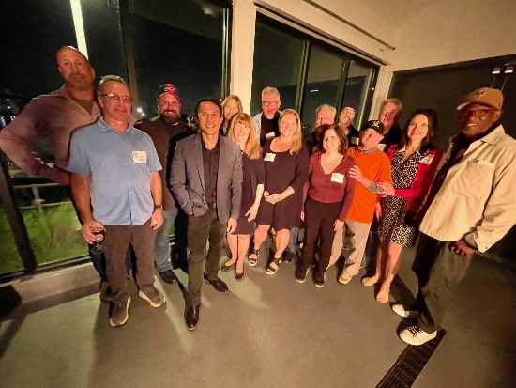

At Buffalo Nite in DC (left) with COM alumni Nadine DiStefano ’96 and Robert Udowitz ’84; and the Southern California alumni gathering (at right)

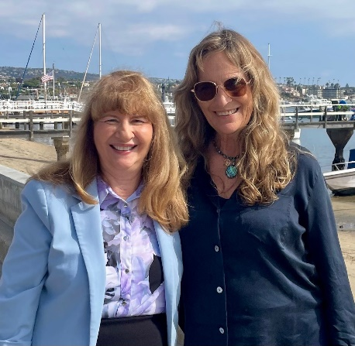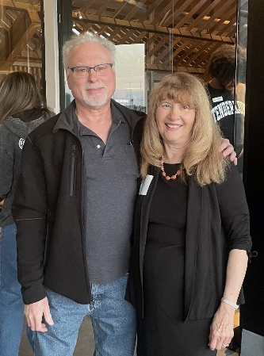
With alumni Darcy Parsons ‘78 and Rich Lippman ’76 in Southern California

I enjoyed learning about the impact of Buffalo State on their lives and their careers since graduating from Buffalo State - and I was so impressed by their achievements!

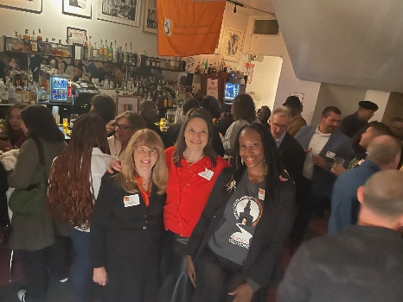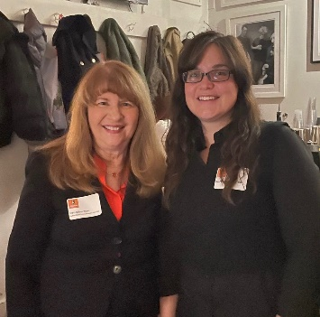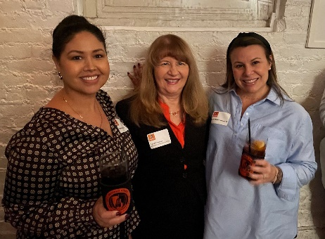
New York City reunion….group photo; with Amber Sherman ’09, a member of COM’s Alumni Advisory Board; and with M.S. in PR alumni Esmeralda Cordero ’23 and Emilie Ballaro Despagni ‘09

Buffalo State’s Alumni Office is planning more reunions in all three cities so make sure your current email address is on file with the Alumni Office if you’re interested in attending!

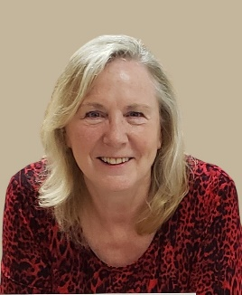
- New Scholarship for Journalism Students – Deborah Gallagher Barger ’76 has established a new Journalism Excellence Scholarship for incoming and current Journalism students who demonstrate journalistic integrity, objectivity, and accuracy. Our sincerest thanks to Ms. Barger for her generosity! The first recipient will be selected for the spring 2025 semester. If you’re interested in creating a scholarship, you can contact Elka Dintcheva, Senior Major Gift Officer in Institutional Advancement, at dintchej@buffalostate.edu or (716) 878-4227.

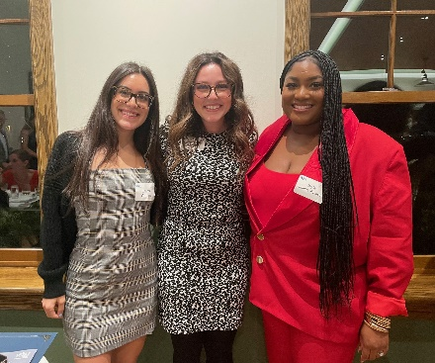
- Public Relations Student Award Winners – Three M.S. in Public Relations students won Student Excalibur Awards for Best PR Campaign from the Buffalo Niagara chapter of the Public Relations Society of America on Sept 26. Emma Cercone, Francesca Harvey, and Jayla Collins-Faison, all 2024 graduates of our program, created their campaigns for my COM 690 Master’s Project course last spring. Congratulations!

L-R: Emma Cercone, Francesca Harvey, Jayla Collins-Faison

- PBS Film by COM Alumni – Joana Leamon ’23 directed the short film “Buffalo Historia: The Surprising Origin of the Mexican National Anthem,” which was produced at Buffalo’s WNED-TV with production assistance from alums Danielle Gabamonte and Joe Scordo, and involving recent grads Karla Dobozin and Ethan Taylor Sweet as production interns. Check it out here! https://www.wned.org/television/program-highlights/hispanic-heritage/

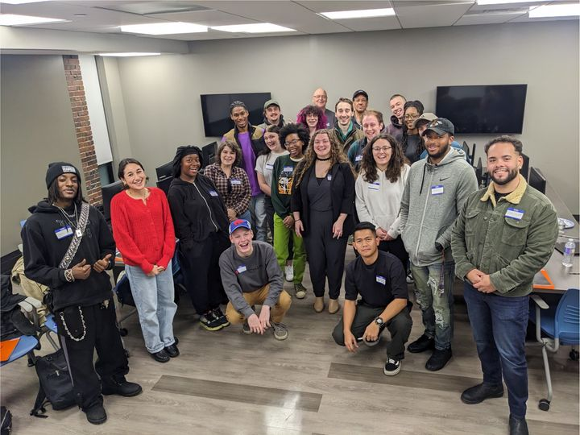
- Post-Production Diversity Initiative - COM's new Post-Production Diversity Initiative (PPDI) held its orientation Nov. 1! Participants got to connect with one another, pairing up to answer questions about what inspired them to pursue working in post-production. They also reviewed the schedule for the sessions that PPDI will be hosting during the year-long program from November 2024 to August 2025. PPDI is a collaboration between Buffalo State University, the Motion Picture Editors Guild – New York, the media company Avid, and Buffalo FilmWorks. Funded by a New York State Entertainment Workforce Diversity Grant, PPDI is a one-year program that prepares participants from diverse backgrounds, including Buffalo State students and community members, for entry-level careers in video editing and audio mixing in the highly competitive music, video, and media industries. The grant proposal was written by COM Professor Dorothea Braemer, with Robin Lazzara as the project manager.
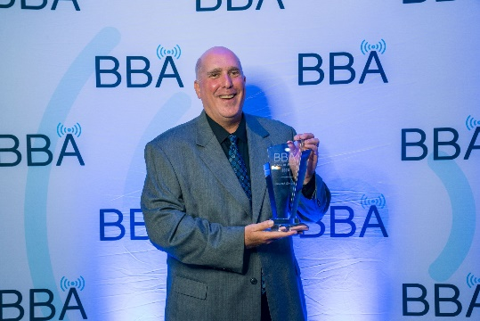
- Alumni Receive Broadcasting Awards – Congratulations to three COM alumni for their achievements in broadcasting! The Buffalo Broadcasters Association inducted retired broadcasters Jim DiMino ’75 and Howard Simon ’84 into its Hall of Fame, and Joe Cali ’24, who is employed by WGR Sports Radio and News Radio 930 WBEN, received the Rising Star Award at BBA’s annual Hall of Fame awards dinner on Sept. 19. 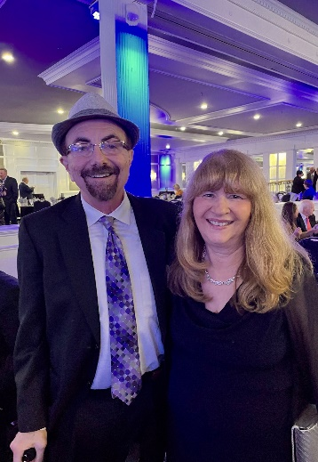 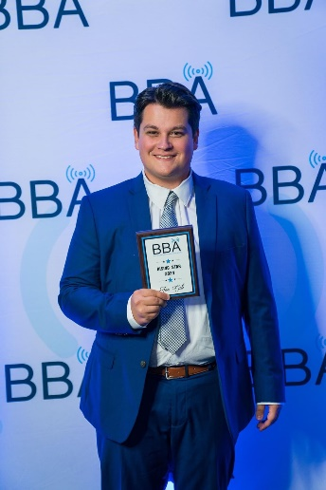
L-R: Howard Simon, Jim DiMino (with me) and Joe Cali at the BBA awards dinner.

- Media Production Students Win National Awards – Two music videos produced through a collaboration between COM 431 (spring ‘22) and COM 432 (spring ‘22) and COM 431 (fall ‘23) and COM 328 (fall ‘23) have won Broadcast Education Association (BEA) Student Festival of Media Arts Awards! The 2024 BEA festival received nearly 1,900 submissions from more than 300 colleges and universities. Buffalo State won two out of six music video awards.

"Movin' On," a music video made in collaboration with musician Drea D'Nur, won first prize in
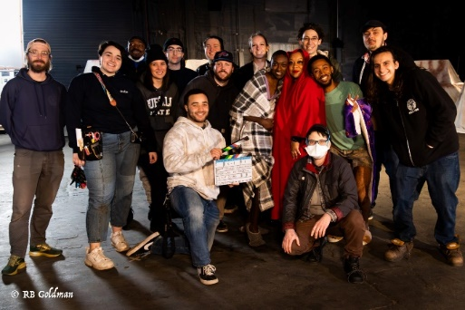
the Music Video category. "There is Power," a music video made in collaboration with musician Michael Solo Farrow, won an award of excellence.

"Movin' On" (photo at left) was made in Professor Ruth Goldman's spring 2022 COM 431 course and edited in Professor Dorothea Braemer's COM 432 course. "There is Power" (photo below) was made in Professor Ruth Goldman's fall 2023 COM 431 course and edited in Professor Meg Knowles' COM 328 class.
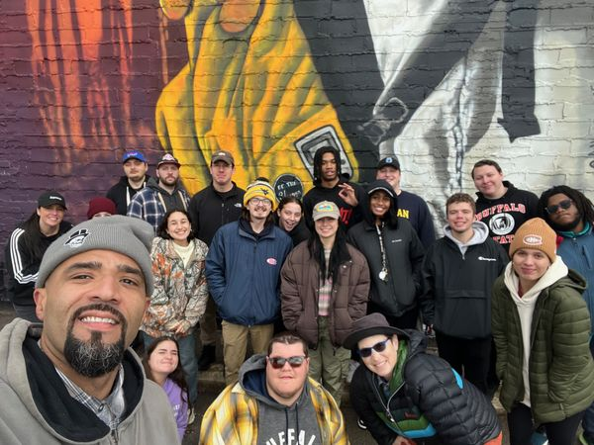

Congratulations to all of these students and faculty for their outstanding work!

- Professional Achievement and Emerging Leader Award Winners – On Nov. 8, the Communication Department honored nine outstanding alumni at its annual Alumni Awards/Honor Society Induction event. Congratulations to Professional Achievement Award recipients Kimberly LaRussa ’11, Brian Rickert ’74, Joe Kirchmyer ’84, and Matthew Davison ’12; and Emerging Leader Award winners Tiffany Gaines ’17, Katelyn Kardaman ’20, Kelly Khatib ’17, Mary Luff ’16, and Thomas O’Neil-White ’16! We also inducted 24 students into our Rho Psi chapter of the Lambda Pi Eta National Communication Honor Society. Buffalo State Interim President Dr. Bonita Durand was our guest speaker.
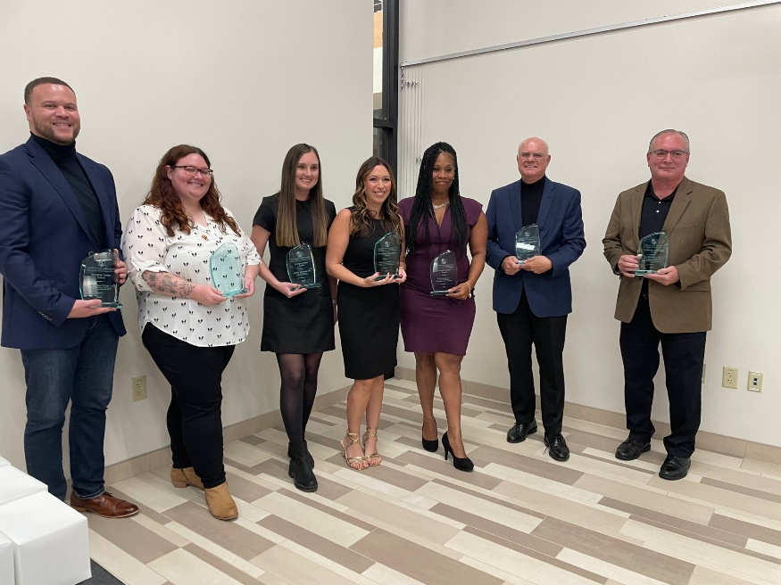
L-R: Alumni award recipients Thomas O’Neil-White, Mary Luff, Katelyn Kardaman, Kimberly LaRussa, Kelly Khatib, Brian Rickert, and Joe Kirchmyer. Tiffany Gaines and Matthew Davison were absent when the photo was taken.

- Alumni Guest Speakers – We’re fortunate to have COM alumni as frequent guest speakers in our classes, either virtually or in person! Here are photos of a couple of recent speakers. 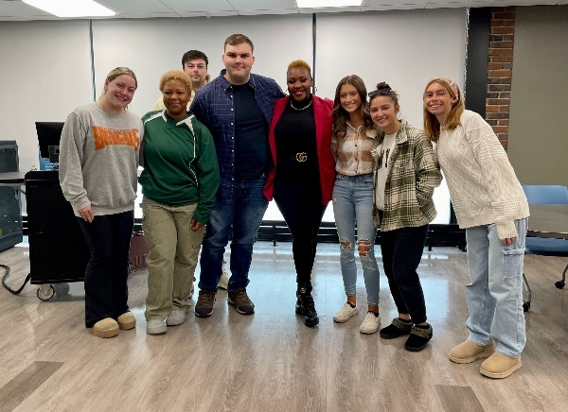 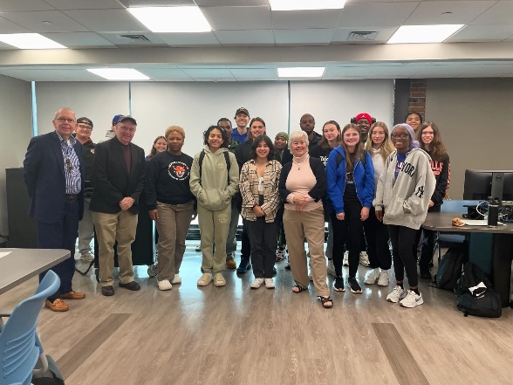
At left: Porsha Ari Parson ’18 with Public Relations Society of America students; at right, Maura Casey ’78 (at center) in Professor Stanton Hudson’s COM 210 Media Writing class.

If you’re interested in speaking, you can email me or one of our other professors!

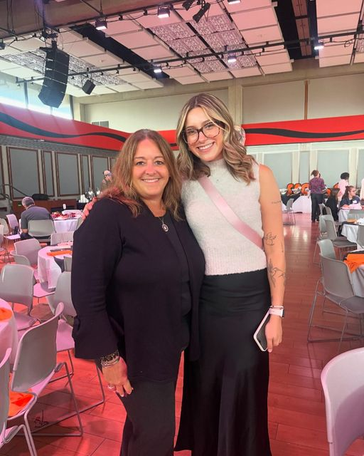
- Second Recipient of Dianne Baumert-Moyik Scholarship – Congratulations to Morgan Stearns, a Public Relations & Advertising senior, as the second recipient of the Dianne Baumert-Moyik Journalism-Public Relations Scholarship! Ms. Baumert-Moyik ‘87 (at left), who met Morgan at Buffalo State’s annual Scholar-Donor breakfast Sept. 21, endowed the scholarship to help Journalism and PR-Advertising students defray non-tuition costs of their education.

- Please Stay in Touch! – We’d like to have COM alumni involved with our department! You can share your career success stories with us, be a virtual guest speaker in a class, participate in our virtual “Meet the COM Professionals” events on Zoom, alert us to internships and job opportunities, join our Alumni Advisory Board, donate money for scholarships, or follow us on our social media platforms (Facebook, Instagram, and LinkedIn). For details, contact me at silverda@buffalostate.edu or call the Communication Department weekdays between 8 a.m. and 3 p.m. at (716) 878-6008.
Looking forward to hearing from you!

Dr. Deborah Silverman, Communication Department Chair

