
Welcome to the Spring 2026 edition of Communication Department News! We’d like to update our alumni on happenings in our department. (If you wish to unsubscribe, please reply to this email.) Here’s the latest news:
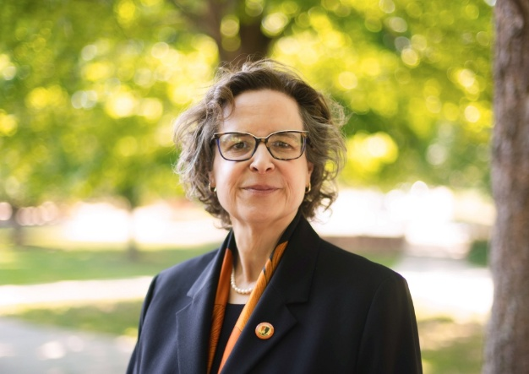
- New Buffalo State President – Dr. Jennifer Burris has been appointed as the 11th President of SUNY Buffalo State by the SUNY Board of Trustees, effective July 1, succeeding Dr. Bonita Durand. A physicist and an accomplished academic leader, Dr. Burris is currently Vice President for Academic Affairs at Lenoir-Rhyne University in Hickory, North Carolina, where she has led efforts to advance student success and academic innovation. She said she was attracted to Buffalo State because of its place as SUNY’s urban-engaged anchor institution and its reputation as a powerhouse for social mobility to create life-changing opportunities for first-generation and transfer students. Welcome, Dr. Burris!

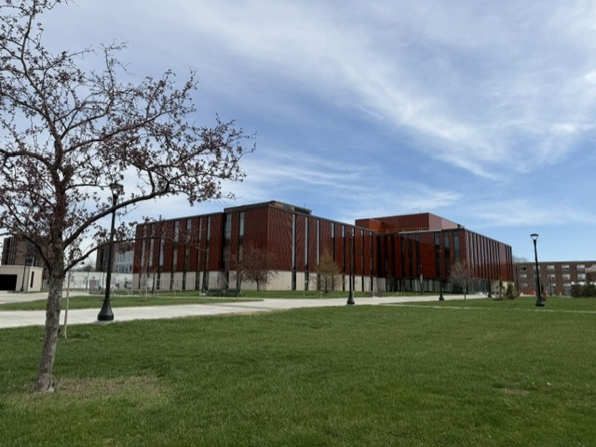
- Communication Department to Move – The Communication Department will move its department and faculty offices from Buckham Hall to the newly renovated Elms Hall (the former Classroom Building) in late December, in time for the start of the spring 2027 semester. We’ll be on the second floor in Wing 3 (the former C Wing) facing Houston Gym. Elms Hall is centrally located on campus, with many academic departments and the Dean of Arts and Sciences Office set to move there next spring and summer. COM has been based in Buckham Hall since summer 2017; previously we were located in Bishop Hall. If you’re on campus, stop by to say hello!

New Scholarship and Paid Internship for Journalism Students – An anonymous donor has created the Joshua Lidsky Endowed Journalism Scholarship and Internship Fund, honoring former Journalism student Joshua Lidsky, who died in 2002.

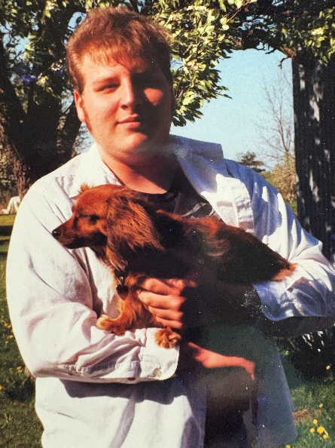
The Scholarship Fund will provide one $4,000 scholarship annually to one student pursuing a degree in Journalism. Eligible students will have a GPA of 2.5 or higher. Preference will be given to students working at Buffalo State’s student-run radio station, WBNY-FM, where Joshua served as general manager.

The Internship Fund will provide two $2,000 internship stipends annually to students pursuing a degree in Journalism. Eligible students will have a GPA of 2.5 or higher, with preference given to students working at WBNY-FM.

We are extremely grateful to the anonymous donor for these gifts! If you’re interested in creating a scholarship, you can contact Elka Dintcheva, Senior Major Gift Officer in Institutional Advancement, at dintchej@buffalostate.edu or (716) 878-4227.
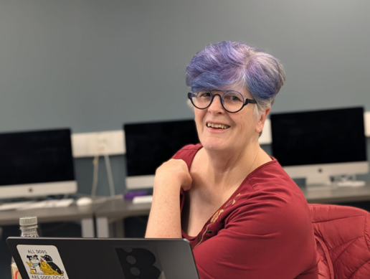
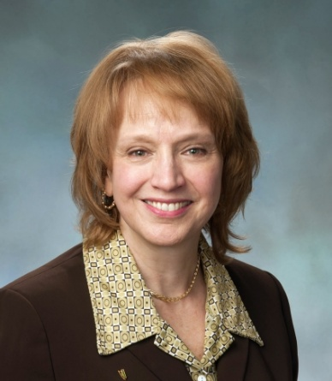
- Retirements of Professors Franczyk and Knowles – The Communication Department is bidding a fond farewell to two long-time professors, Meg Knowles (Media Production), who is retiring Sept. 1; and Annemarie Franczyk (Journalism), who retired last December. Annemarie began teaching for us part-time in 1992, joining us full-time in fall 2008, while Meg joined us full-time in fall 2006. Both were responsible for major revisions of the curriculum in their respective majors and both were faculty advisers to student organizations – Annemarie as adviser to the student newspaper, The Record, and Meg as adviser to Bengal Film and Television

Meg Knowles
Productions (formerly BSC-TV). Meg also co-founded Buffalo State’s “Beyond Boundaries” film series with Professor Ruth Goldman and is a former coordinator of Buffalo State’s Women, Gender, and Sexuality Studies interdisciplinary unit. Annemarie is responsible for our partnership with the Buffalo Broadcasters Association, having served on its board, currently as its secretary, and she led our department’s efforts to become a founding member of SUNY’s Institute for Local News. We thank them for their many years of outstanding service to our students, department, and Buffalo State, and wish them many happy years in retirement!
Annemarie Franczyk
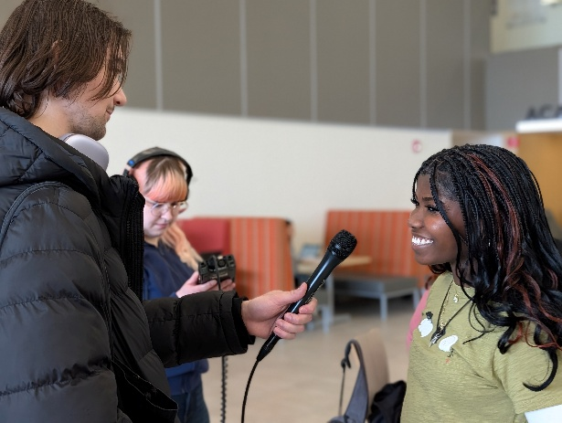
- Radio and TV Shows – The Communication Department is continuing to give students valuable broadcasting experiences that can lead to jobs after graduation. WBNY-FM’s “Let’s Talk Buffalo,” on air since 2019, is a weekly half-hour public affairs show that airs Monday through Friday at 10 a.m., with Professor Dorothea Braemer as the faculty adviser.

Our “Broadcasting Buffalo” television series, a collaboration between COM and the Buffalo
Broadcasters Association, is produced by two Journalism classes in the spring semester:
COM 347 Digital & Broadcasting Producing taught by Professor Ellen Notarius, and COM
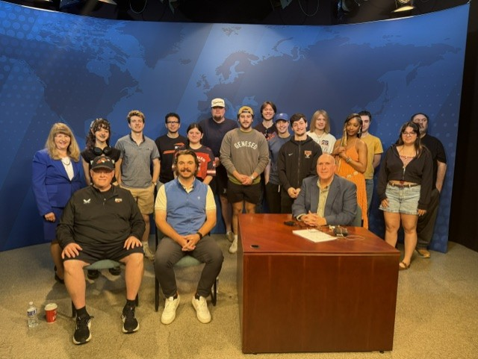
334 Journalism Broadcast Operation taught by Professor Rick Karnath. The series, which just finished its fifth season, airs on Saturdays at 6:30 p.m. on WNYO-TV in Buffalo. The
episode shown here featured three COM alumni, all sports broadcasters, talking about the Buffalo Bills, the Buffalo Sabres, and the Buffalo Bandits: host Howard Simon ’84 (retired from WGR 550 SportsRadio), Nate Geary ’15 (WGR 550 SportsRadio), and Chris Swenson ’86 (Buffalo Bandits).

To date, more than a dozen students who worked on one or both of these shows have landed jobs in broadcasting!

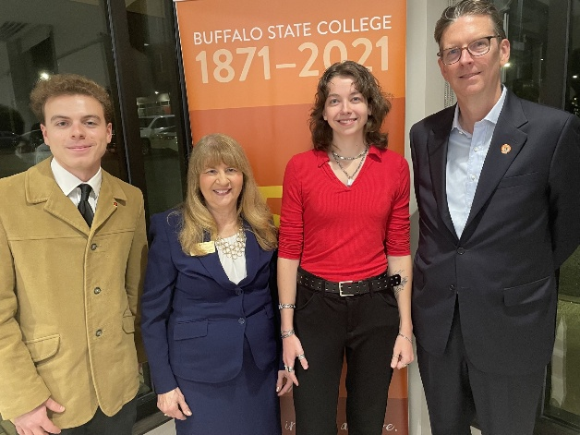
- Hall of Fame Award Winner – Last November, the Communication Department inducted Brian Hartman, Senior Coordinating Producer at ABC News in New York City, into our Hall of Fame, our national-level award for achievements in communication. As a Buffalo State political science major, he was President of United Students Government, student member of the SUNY College Council, delegate to the New York State Student Assembly, a reporter for The Record student newspaper, and a music DJ at WBNY-FM. He is shown at our November induction ceremony (at right) with Journalism students Matt Barton and Grace Cole and me. Congratulations to Brian on his outstanding career!

(photo, left to right: Matt Barton, Deborah Silverman, Grace Cole, Brian Hartman)

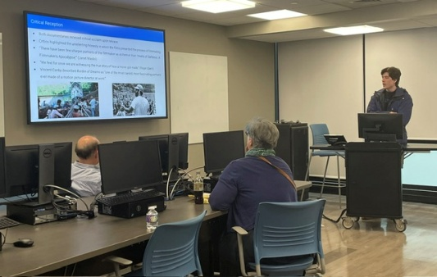
- Spring Student Showcase and Fall Forum – Communication students had the opportunity to share their research and creative works at two events on campus this year. Our own Fall Forum on Nov. 14, chaired by Professor Ann Liao, featured dozens of student presenters.

Fall Forum

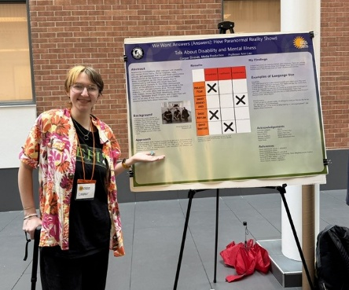
Buffalo State’s first-ever Spring Student Showcase on May 6 was a university-wide event featuring poster sessions, oral presentations, art exhibits, student performances, and our own MediaFest showcasing short films by Media Production students. Congratulations to all of these students!

Spring Student Showcase

- Communication Student for a Day – The Communication Department continues to recruit new students through initiatives such as its successful “Communication Student for a Day” event, held for the second time last fall. We welcomed 60 Western New York high school 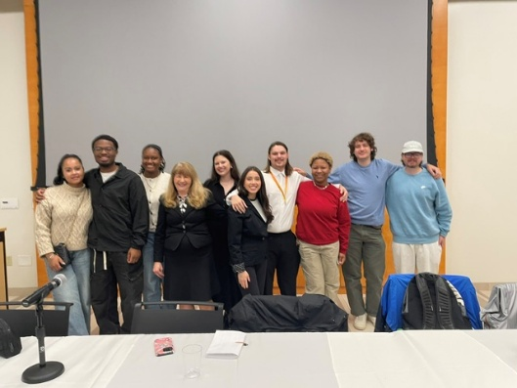 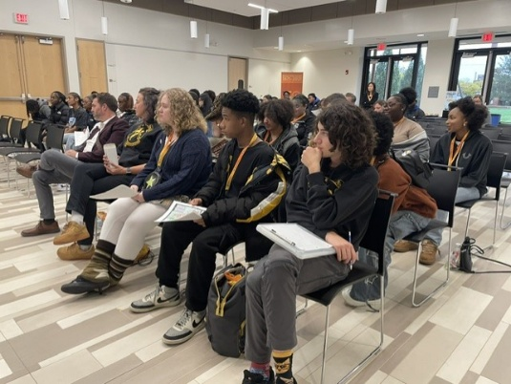
students to campus on Oct.20 for a panel discussion featuring COM alumni and current students, followed by visits to classes and lunch on campus. Our next “Communication Student for a Day” event is slated this fall on Oct. 5.

- M.S. in Public Relations Alumni Reunion – To mark the 10th anniversary of our M.S. in Public Relations program, we’re hosting an alumni reunion for all alumni of our M.S. in Public Relations program and its predecessor, the M.S. in Multidisciplinary Studies/Public Relations track. The reunion is set for 4 p.m. Friday, Sept. 18, at Buffalo State’s Alumni & Visitors Center, followed at 5 p.m. by a general Buffalo State alumni reunion at the same location. Both events are part of Buffalo State’s Homecoming Weekend. Check your email for details or email me at silverda@buffalostate.edu for more information.

- Please Stay in Touch! – We’d like to have COM alumni involved with our department! You can share your career success stories with us, be a virtual guest speaker in a class, participate in our virtual “Meet the COM Professionals” events on Zoom, alert us to internships and job opportunities, join our Alumni Advisory Board, donate money for scholarships, or follow us on our social media platforms (Facebook, Instagram, and LinkedIn).

If you’re planning a visit to Buffalo and would like to stop by our department, let me know! For details about any of these opportunities, contact me at silverda@buffalostate.edu or call the Communication Department weekdays between 8 a.m. and 3 p.m. at (716) 878-6008.
Looking forward to hearing from you!

Dr. Deborah Silverman, Communication Department Chair

