
Welcome to this edition of Communication Department News! We’d like to update our alumni on happenings in our department. (If you wish to unsubscribe, please reply to this email.) Here’s the latest news:


- ‘Day of Giving’ Benefits Ronald D. Smith Memorial Scholarship – Buffalo State’s Day of Giving in March yielded more than $7,000 towards a new scholarship to honor our late Professor Ron Smith, former Communication Department chair and Public Communication (PR/Advertising) faculty member. The scholarship will go to a Buffalo State Communication student planning a career in the field, with preference given to those entering public relations, Professor Smith’s own field. Our sincerest thanks to those who donated during the Day of Giving campaign! You can still donate here: https://www.justgiving.com/campaign/buffalostate-ronsmith.

- Media Production Students Win National Awards – Two music videos produced through a collaboration between COM 431 (spring ‘22) and COM 432 (spring ‘22) and COM 431 (fall ‘23) and COM 328 (fall ‘23) have won Broadcast Education Association (BEA) Student Festival of Media Arts Awards!


"Movin' On," a music video made in collaboration with musician Drea D'Nur, won first prize in
the Music Video category. "There is Power," a music video made in collaboration with musician Michael Solo Farrow, won an award of excellence.

"Movin' On" (photo at left) was made in Professor Ruth Goldman's spring 2022 COM 431 course and edited in Professor Dorothea Braemer's COM 432 course. "There is Power" (photo below) was made in Professor Ruth Goldman's fall 2023 COM 431 course and edited in Professor Meg Knowles' COM 328 class.

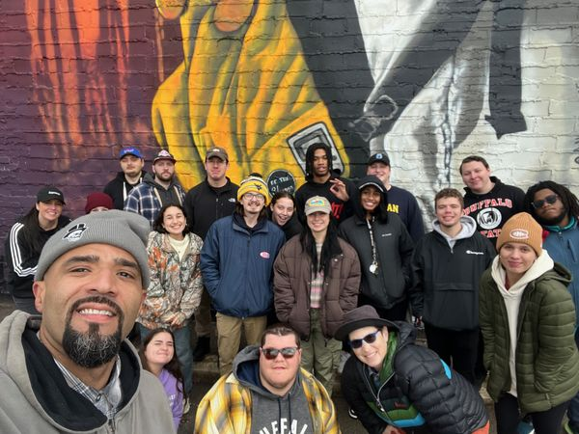

The BEA festival received close to 1,900 submissions from more than 300 colleges and universities. Buffalo State won two out of 6 music video awards.

Congratulations to all of these students and faculty for their outstanding work!

- SUNY Institute for Local News – Our Journalism program is a founding member of a new SUNY-wide initiative, the SUNY Institute for Local News. The Institute highlights SUNY journalism classes that report on news in “news deserts” communities that lack local news media outlets. Journalism Professor Annemarie Franczyk represents the Buffalo State Communication Department on the Institute. The Communication Department has several journalism courses that report on community news, including COM 405 Field Reporting, COM 347 Digital & Broadcast Producing, and COM 389 Digital Sports Journalism.

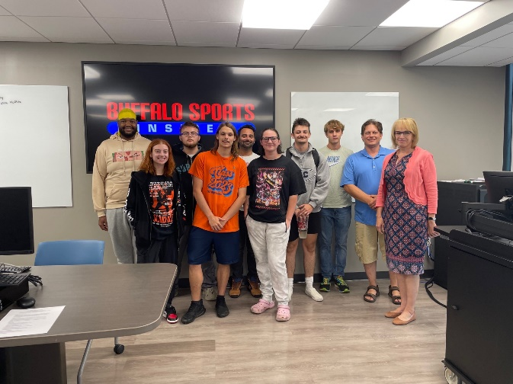
Field Reporting students cover news stories on Buffalo’s West Side and upload them to Buffalo Review West. Students in COM 347 partner with students in COM 389 Broadcast Practicum on the weekly TV show “Broadcasting Buffalo,” which airs during the spring semester on WNYO-TV, while students in Digital Sports Journalism (photo at left) host livestream shows plus web and social media content about the Buffalo Bills, Buffalo Sabres, and other sports teams. Check out Buffalo Sports Insider for details!

- Hall of Fame Award Winners – In November, the Communication Department inducted two former students into its Hall of Fame, our award for national-level achievements.
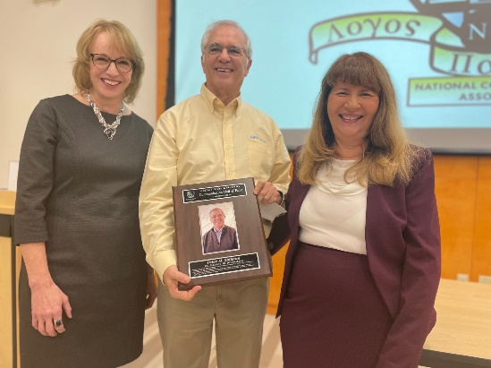
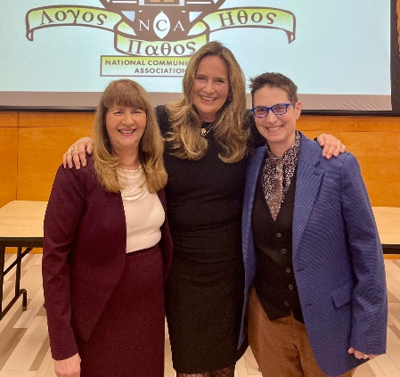

Congratulations to Peter Zollman, journalist and founding principal of the Advanced Interactive Media Group, and Darcy Parsons ‘78, owner/founder of visual effects studio Kevin VFX - we were delighted to have them speak to our students who were inducted into the Communication Honor Society during the event! Mr. Zollman is shown in the photo at left with Journalism Professor Annemarie Franczyk and me; Ms. Parsons is shown in the photo at right (in the middle), with Media Production Professor Ruth Goldman (at right) and me.

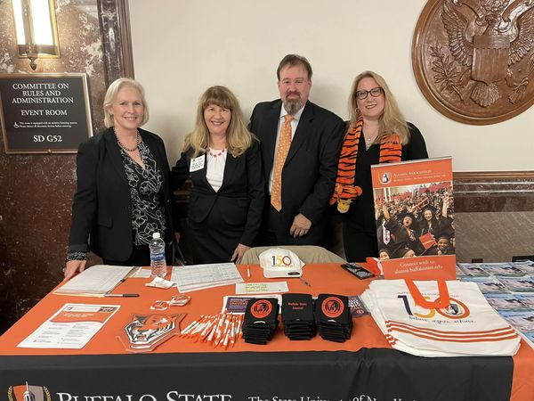
- Alumni Reunions – Last fall, I had the pleasure of meeting with COM alumni at two events. The first, for Buffalo State alumni in the Washington, DC area, took place Sept. 27 at Buffalo Nite in DC, an event for ex-Buffalo residents at the Dirksen Senate Office Building. Thanks to COM alumni Robert Udowitz and Nadine DiStefano for staffing the Buffalo State table with me! U.S. Senator Kirsten Gillibrand (at left) joined us for this photo.

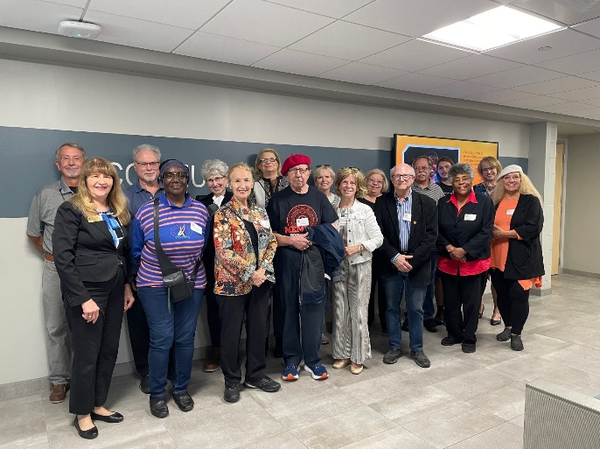
The second event, on Oct. 6, brought 15 Communication alumni back to campus for a tour of our current facilities in Buckham Hall and Savage Building, WBNY-FM, and a get-together at Campus House. It was great to talk with so many alumni at these two events. Plans are in the works for alumni gatherings later this year in New York City, Southern California, and Washington, DC – stay tuned!

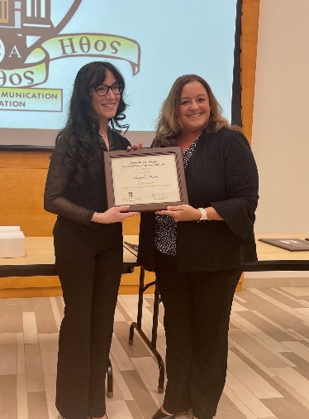
- First Recipient of Dianne Baumert-Moyik Scholarship – Congratulations to Journalism senior Angela Caico as the first recipient of the Dianne Baumert-Moyik Journalism-Public Relations Scholarship!

Ms. Baumert-Moyik (shown at right in photo) made the presentation to Ms. Caico during our Hall of Fame Awards/Honor Society Induction in November. Ms. Caico is editor-in-chief of our student newspaper, The Record.

- Stay in Touch! – We’d like to have COM alumni involved with our department! You can share your career success stories with us, be a virtual guest speaker in a class, participate in our virtual “Meet the COM Professionals” events on Zoom, alert us to internships and job opportunities, join our Alumni Advisory Board, donate money for scholarships, or follow us on our social media platforms (Facebook, Instagram, and LinkedIn). For details, contact me at silverda@buffalostate.edu or call the Communication Department weekdays between 8:30 a.m. and 4 p.m. at (716) 878-6008.
Looking forward to hearing from you!

Dr. Deborah Silverman, Communication Department Chair

