
Welcome to the Summer 2025 edition of Communication Department News! We’d like to update our alumni on happenings in our department. (If you wish to unsubscribe, please reply to this email.) Here’s the latest news:
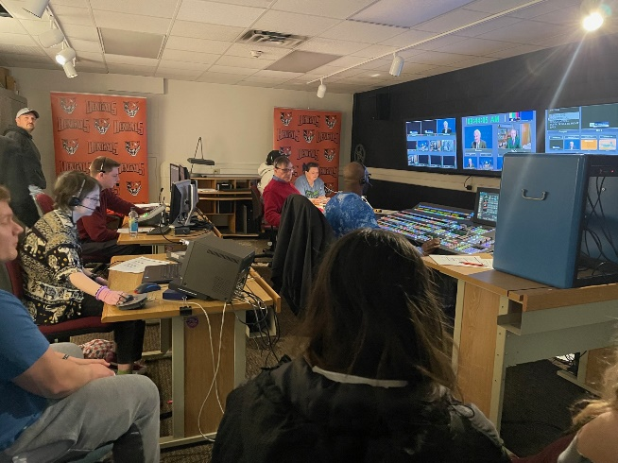
- Journalism Program Revision – Buffalo State has approved a revision of our Journalism program that reflects the dramatic evolution of the journalism industry since the Journalism program’s last revision in 2010. The latest revision combines writing and broadcast/digital journalism into multimedia courses and adds a broadcast operation course and an experiential course requirement to the curriculum. The updated Journalism major will increase the credit hours from 42 to 45 in a plan of coursework that will better prepare students to enter this dynamic field that supports democracy in America.

Professor Rick Karnath’s new COM 334 Journalism Broadcast Operation class
Kudos to Journalism Professor Annemarie Franczyk for her hard work on the program revision! It goes into effect this fall.

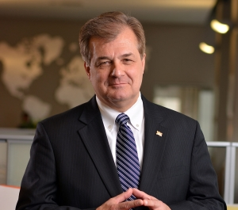
New Scholarship for Journalism Students – Lia DePerro, widow of Donald DePerro ’81 (B.A., Journalism), has created the Donald DePerro ’81 Endowed Journalism Scholarship Fund to honor her late husband, who died in January. He was editor of The Record as a Buffalo State student and later went on to a successful career in print journalism, most notably as president and publisher of Business First in Columbus, Ohio (1996-2016), followed by eight years as president and CEO of the Columbus Chamber Commerce. The $2,000 scholarship will be presented annually to a Journalism student who meets the following criteria:
- Sophomore or junior pursuing a degree in Journalism.
- Have a GPA of 2.5 or higher.
- Be in good academic standing.
- Must submit an essay of at least 500 words on the role of journalism in a democracy.
- Preference will be given to a student working at the Buffalo State student newspaper, The Record.
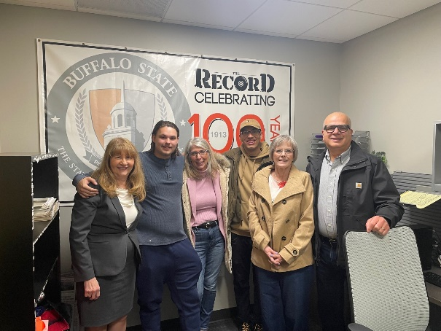
I had the pleasure of meeting with Mrs. DePerro and her family on campus in April, when I introduced her to current student leaders of The Record. Our sincerest thanks to her for her generosity! If you’re interested in creating a scholarship, you can contact Elka Dintcheva, Senior Major Gift Officer in Institutional Advancement, at dintchej@buffalostate.edu or (716) 878-4227.

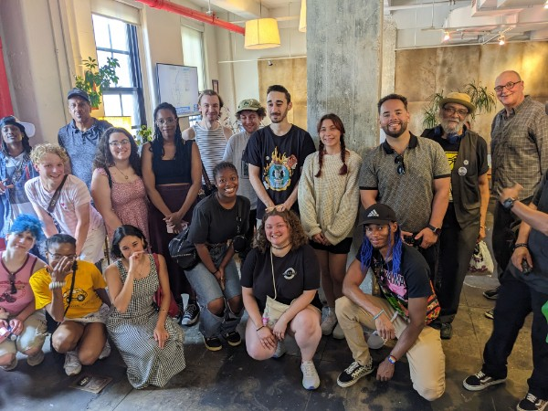
- Post Production Diversity Initiative – COM's Post Production Diversity Initiative (PPDI) is wrapping up its first year of operation this summer! PPDI is a one-year program, funded by a New York State Entertainment Workforce Diversity Grant, that prepares 22 participants from diverse backgrounds for entry-level careers in video editing and audio mixing in the highly competitive music, video, and media industries. Participants capped off a year of intense study, mentorship and lessons by professional editors and sound mixers with a trip to New York, where they visited 4 different post-production and audio mixing studios.

Pictured here are all participants at The Sound Lounge, an audio mixing facility in Manhattan that mixes the sound for TV shows such as The Bear and Sesame Street. Four participants have already secured work in the post-production field as a direct result of their training at PPDI. Buffalo State Media Production Professor Dorothea Braemer, founder and chief investigator of PPDI, and Robin Lazzara, PPDI’s program manager, are awaiting approval for a second year of funding of this successful and unique initiative.

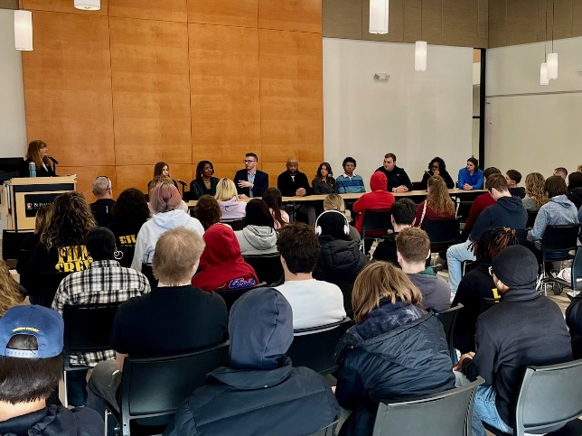
- Communication Student for a Day – Several COM alumni and current students participated in a panel discussion March 10, when COM welcomed 65 Western New York high school students for a new recruitment initiative, Communication Student for a Day. The event began with a panel discussion about Communication majors and careers, including a Q&A with the audience, followed by visits to classes, including a taping of our TV show “Broadcasting Buffalo,” and lunch on campus. “Broadcasting Buffalo” is produced by two Journalism classes, COM 347 Digital & Broadcast Producing (Professor Ellen Notarius) and COM 334 Journalism Broadcast Operation (Professor Rick Karnath), in collaboration with the Buffalo Broadcasters Association.

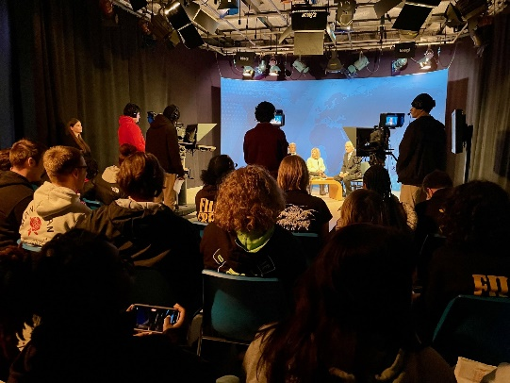
My thanks to Communication alumni Claudine Ewing, Evan DiPasquale, Kandis Fuller, Charles Gilbert, and Amber Witzleben, and students Hannah Steiner, John Whipple, Thomas Bailey, and Mario Campo and all of the Communication faculty who hosted our visitors! We are planning another Communication Student for a Day event this fall.

“Broadcasting Buffalo” TV Show

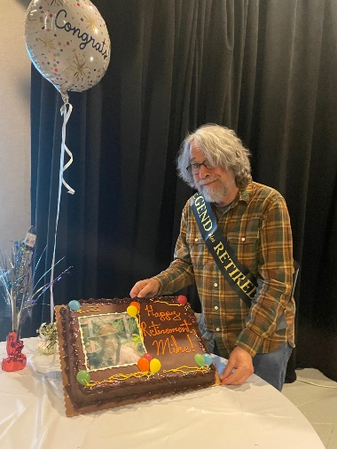
- Professor Niman Retires – Colleagues of Professor Michael Niman honored him at a retirement party in May, capping a Buffalo State teaching career that began in the 1990s when Mike was an adjunct professor.

Dr. Niman, who taught courses in our Communication Studies and Journalism majors, joined us full-time as an assistant professor in 2002 and was promoted to associate professor in 2007 and then full professor in 2012. During that time, he won multiple awards, including the SUNY Chancellor’s Award for Excellence in Teaching. As an emeritus professor, he’s looking forward to teaching a class for us from time to time. All the best to Mike for many happy years to come!

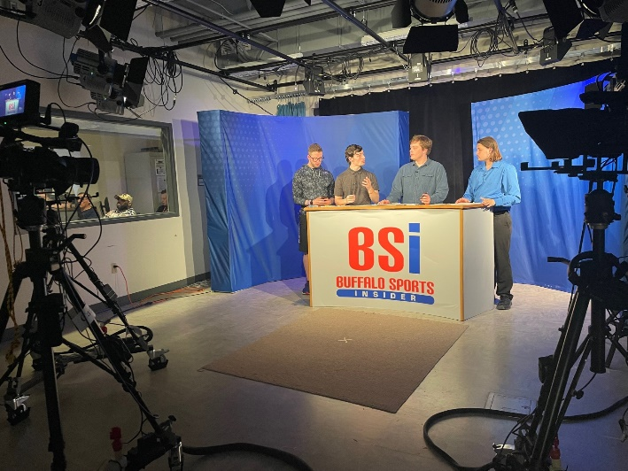
- Sports Journalism Students Livestream about the NFL Draft – Our COM 403 Digital Sports Journalism students had a busy night on the first night of the NFL Draft on April 24! The class, which does a weekly livestream for “Buffalo Sports Insider” on YouTube about Buffalo’s professional and collegiate sports teams, did a special livestream for the NFL Draft in the TV studio in the Technology Building. The spring 2025 course was taught by Professor Annemarie Franczyk with the Buffalo Broadcasters Association (president Steve Monaco) as our partner. It’s a great way for students to learn about livestreaming in the journalism field.
- Alumni Guest Speakers – COM master’s in PR alumni Matt Davison and Shantel Coleman of The Martin Group, an integrated communication agency based in Buffalo, hosted a visit from our Public Relations Student Society of America chapter in February.
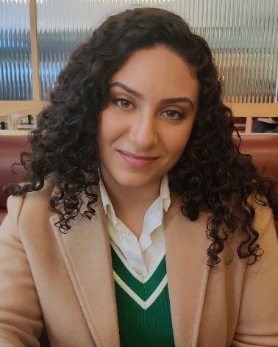
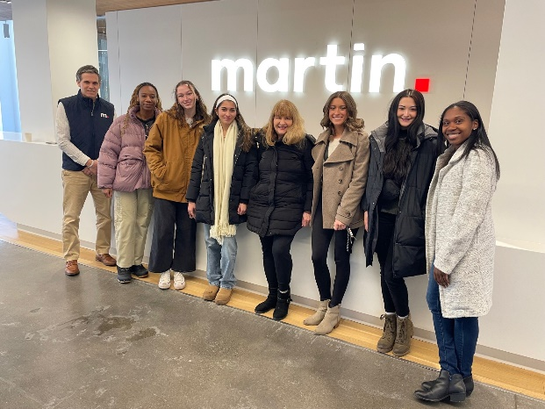

Another COM graduate, Narmeen Karzoun ’13 (Journalism), gave a virtual presentation this spring to PR students about her job as digital and media manager for jewelry company Swarovski North America in New York City. They are among dozens of Communication alumni who speak to our classes virtually or in-person each year. If you’re interested in speaking, you can email me or one of our other professors.

- “Meet the COM Professionals” Event - Our thanks to five Communication alumni who were guest speakers on March 18 at our annual "Meet the COM Professionals" virtual career event for our current students via Zoom! Our speakers included Jocelyn Gonzalez, social media manager for The Apollo Theater in Harlem; Darra Kubera, communications director for UB's School of Architecture and Planning; Khalil Carr, marketing production manager for New Era Cap in Buffalo and Buffalo Fashion Week founder; Alexander Harold, executive director of photography & videography at Haute LaVie and founder of Creative Connect; and Shantel Coleman, public relations specialist at The Martin Group in Buffalo. They gave excellent advice on launching communication careers!
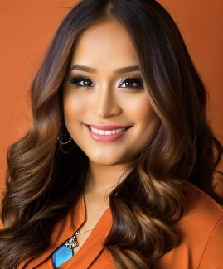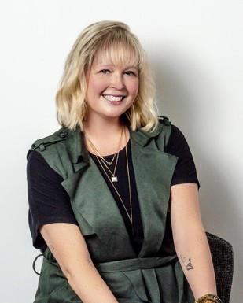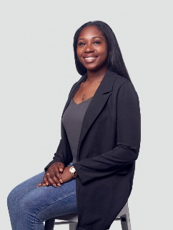

- Faculty Honors and Awards – Congratulations are in order for the following Communication faculty!
- Professor Ann Liao (Communication Studies) on being named as a recipient of a 2025 SUNY Chancellor’s Award for Excellence in Teaching.
- Professor Annemarie Franczyk (Journalism) as 2025 recipient of Buffalo State’s Leadership in Community Engagement Award for courses that serve local “news deserts,” her volunteer work on the Buffalo Broadcasters Association board, and her service on the SUNY Institute for Local News.
- Professor Ruth Goldman (Media Production), honored as a 2025 Community Service Honoree by Embrace Western New York, which seeks to raise awareness understanding, and acceptance of the LGBTQ+ community among all citizens.
- Professor Deborah Silverman (PR/Advertising), named in May as vice chair of the national Commission on Public Relations Education, which provides research-based recommendations to enhance the quality of public relations programs at universities around the world.

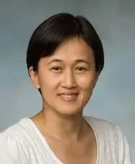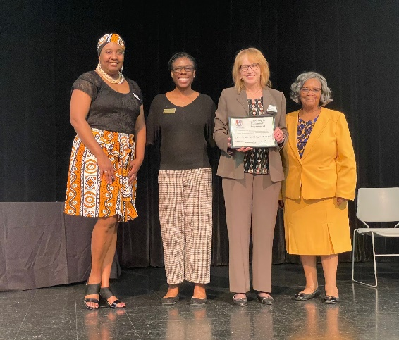

Professor Liao Professor Franczyk (second from right)

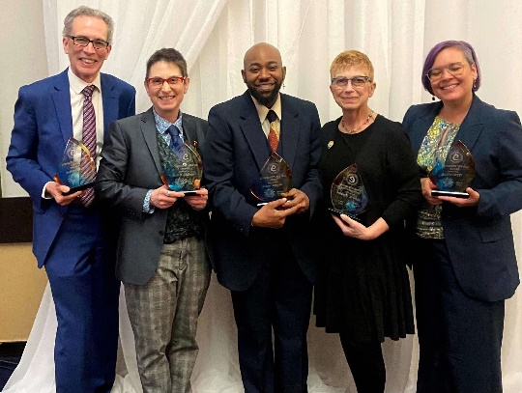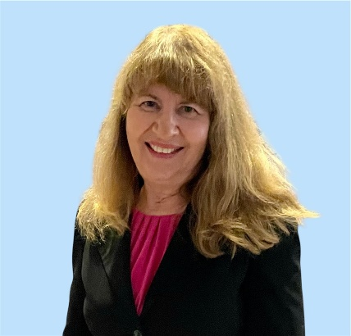
Professor Goldman (second from left) Professor Silverman

- Please Stay in Touch! – We’d like to have COM alumni involved with our department! You can share your career success stories with us, be a virtual guest speaker in a class, participate in our virtual “Meet the COM Professionals” events on Zoom, alert us to internships and job opportunities, join our Alumni Advisory Board, donate money for scholarships, or follow us on our social media platforms (Facebook, Instagram, and LinkedIn).

If you’re planning a visit to Buffalo and would like to stop by our department, let me know! For details about any of these opportunities, contact me at silverda@buffalostate.edu or call the Communication Department weekdays between 8 a.m. and 3 p.m. at (716) 878-6008.
Looking forward to hearing from you!

Dr. Deborah Silverman, Communication Department Chair

