
Welcome to this edition of Communication Department News! We’d like to update our alumni on happenings in our department. (If you wish to unsubscribe, please reply to this email.) As we prepare for the fall 2023 semester, here’s what’s happening:
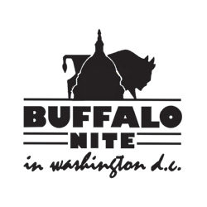
- Alumni Reunion in DC – COM alumni who live in the Washington, DC area are invited to join other Buffalo State alumni and former Buffalonians at Buffalo Nite in DC on Wednesday, Sept. 27! The event is set from 6-9 p.m. at the Dirksen Senate Office Building, Room SDG-50, 1st and C Streets NE, Washington, DC. We’ll be gathering to share lots of Buffalo and Buffalo State memories as well as Buffalo foods (wings, beef on weck, Buffalo-style pizza, sponge candy, and more!). You can register by Sept. 22 on the Buffalo State Alumni Association website at the special discounted ticket price of $30: https://alumni.buffalostate.edu/buffalo-nite-dc-2023.

- Record-WBNY-COM Reunion on Campus – If you’re in the Buffalo area on Friday, Oct. 6, you’re invited to join us from 2:30-4:30 p.m. for a gathering on campus! We’ll tour the Communication Department’s current facilities in Buckham Hall (including The Record’s office) and Savage Building; WBNY-FM; and then Campus House where we’ll enjoy refreshments and share stories from our alumni! The ticket price is $15; you can register by Oct. 1 on the Alumni Association website at: https://alumni.buffalostate.edu/70sreunion.

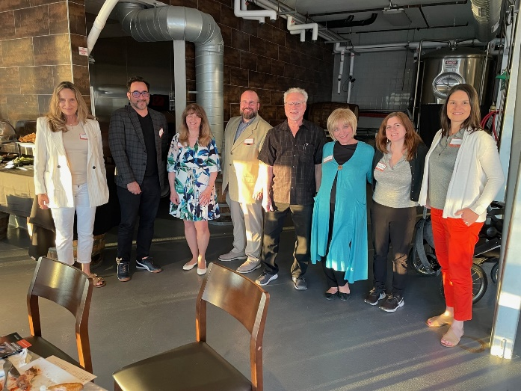
- Southern California COM Reunion – The Communication Department hosted its first-ever SoCal alumni reunion on June 19 at Ballast Point in Long Beach! It was a pleasure to meet alumni and learn about their years at Buffalo State – as well as the earliest years of the Communication Department back in the early 1970s. Thanks to alumni Rich Lippman, Sandy Hodala, Darcy Parsons, Grant Van Leuven, Michael Risucci, Maria Sandone, Tom McNamara, and Robert Tan for joining us! We’re planning another SoCal reunion in 2024.

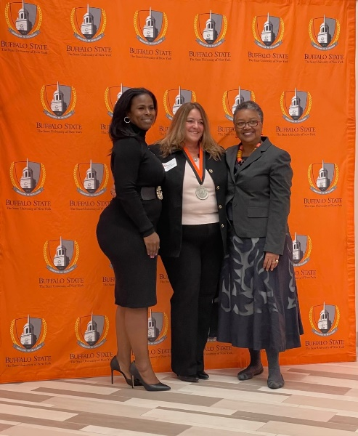
- New Scholarship for Communication Students – Our sincerest thanks to Journalism graduate Dianne Baumert-Moyik ’87 for her generosity in endowing a scholarship! The Dianne Baumert-Moyik Journalism-Public Relations Scholarship provides $1,000 to help defray students’ non-tuition costs. Preference is given to students planning a career in journalism or public relations, to students majoring in our M.S. in Public Relations and B.A. degrees in Journalism and Public Relations, and to students who work for The Record or are members of our Public Relations Student Society of America chapter. The first scholarship will be presented this fall.

Ms. Baumert-Moyik received Buffalo State’s 2022 Distinguished Alumni Award for her service to Buffalo State in October 2022. She is shown here (at center) at the award program with Alumni Association President Stacy Lewis Beauford (at left) and Buffalo State President Dr. Katherine Conway-Turner.

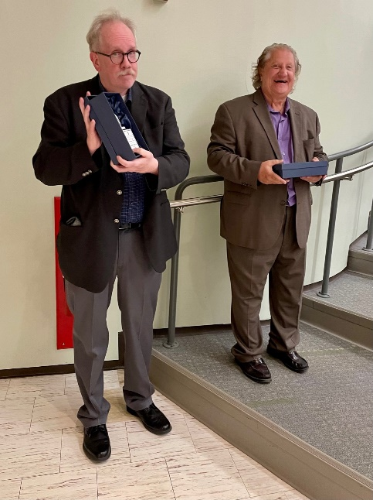
- Retirements – Two beloved professors in the Communication Department wrapped up their teaching careers this spring. Professor Bruce Bryski (Communication Studies), who joined us in 1983, and Professor Joe Marren (Journalism), former department chair, who arrived in 1997, were honored at a retirement party in May. Both are looking forward to traveling in the near future – and Joe will continue to teach part-time as an emeritus professor. We thank them for their many years of outstanding service to our students and wish them all the best – we will miss them!

Professors Joe Marren (at left) and Bruce Bryski at Senior Sendoff in May

- Search for New Buffalo State President – Buffalo State University is reviewing applications for president to replace Dr. Katherine Conway-Turner, who retired at the end of May. Storbeck Search is working with the Presidential Search Committee to identify finalists to bring to campus this fall, with an anticipated start date of January 2024 for the new president. Dr. Bonita Durand is currently serving as Interim President.

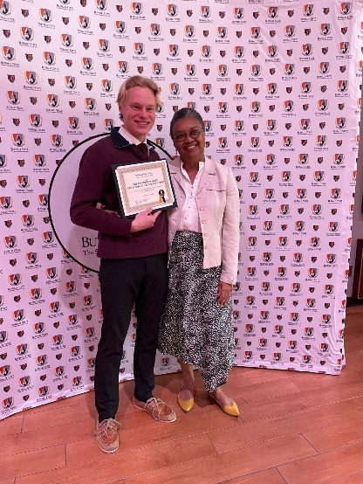
- Top Student – Kudos to Daniel May ’23 (B.A. in Public Relations & Advertising), recipient of Buffalo State’s top undergraduate student award, the President’s Medal for Outstanding Undergraduate Student! Daniel, who gave the student address at commencement in May, served as president of our Public Relations Student Society of America chapter, sports editor of The Record, student representative to the Buffalo State College Council, and vice president of public relations for United Student Government. He’s shown here with Buffalo State President Katherine Conway-Turner.

- Community Engagement Awards – Congratulations to the following individuals and groups who were honored at Buffalo State’s Celebration of Community Engagement in May: COM 650 Public Relations Management students (Professor Deborah Silverman), Outstanding Graduate Service-Learning Course; Buffalo Broadcasting Association and Communication Department, Reciprocal Partnership Award for “Broadcasting Buffalo” (Professors Rick Karnath and Ellen Notarius with BBA President Steve Monaco); Jacob Fleming, Sr. (junior in Media Production), 2023 Campus Compact Newman Civic Fellow; and Elexa Printup (senior in PR & Advertising), “Neighborhood Advocate” award for 400 hours of community service. Great work!

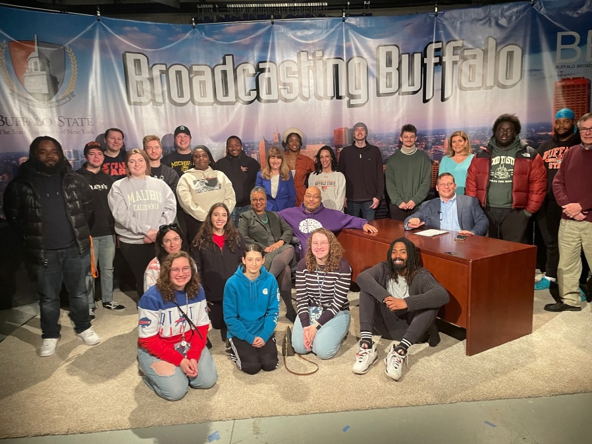
- Award-Winning TV Series – Our news and public affairs TV series, “Broadcasting Buffalo,” is getting ready for its fourth season next spring! The TV series is a partnership between the Communication Department and the Buffalo Broadcasters Association. Students in Professor Ellen Notarius’s COM 337 Electronic News Producing class collaborate with Professor Rick Karnath’s COM 389 Broadcast Practicum course on the shows, which are taped weekly.

The episodes air on WNYO-TV on Saturdays at 6:30 p.m. during the spring semester.

The students, faculty, and guests posed for this photo at the season’s finale in April.


- Alumni Authors – Congrats to two COM alumni from the Class of 1976 who have recently published works: Rich Lippman, the author of “Last Bucket List,” which reimagines how to kickstart a will that’s worthy of your life (https://www.lastbucketlist.com/);



and Moxie Gardiner (Debbie Gallagher at the time of graduation), author of a new novel entitled “Virgin Snow,” which takes place on the West Side of Buffalo. Ms. Gardiner is doing a book signing in Buffalo State’s Student Union at noon on Aug. 31. Here’s a link to her blog with details: https://moxiegardiner.com/2023/07/31/beyond-the-library-the-quiet-evolution-of-literary-buffalo/


- Ronald D. Smith Memorial Scholarship – The Communication Department wishes to honor the late Professor Ron Smith, former Communication Department chair and Public Communication (PR/Advertising) faculty member, with a scholarship in his memory. The scholarship, to be awarded annually each spring, will be given to a Buffalo State Communication undergraduate student planning a career in public relations, with preference given to students in the B.A. in Public Relations and Advertising degree program. Applicants must have a GPA of 3.5 or higher, demonstrate financial need, and possess excellent writing skills, as evidenced by the submission of an essay of 500 words on the importance of strategic planning in public relations.

You can donate here: https://www.justgiving.com/campaign/buffalostate-ronsmith.

- Stay in Touch! – We’d love to have our alumni involved with our department! You can share your career success stories with us, be a virtual guest speaker in a class, participate in our virtual “Meet the COM Professionals” events on Zoom, alert us to internships and job opportunities, join our Alumni Advisory Board, donate money for scholarships, or follow us on our social media platforms (Facebook, Instagram, and LinkedIn). For details, contact me at silverda@buffalostate.edu or call the Communication Department weekdays between 8:30 a.m. and 4 p.m. at (716) 878-6008.
Looking forward to hearing from you!

Dr. Deborah Silverman, Communication Department Chair

