
Welcome to this edition of Communication Department News! We’d like to update our alumni on happenings in our department. (If you wish to unsubscribe, please reply to this email.)
Here’s the latest:
- Back to Campus – This fall, most Buffalo State courses (approximately 80 percent) will once again be offered in-person, including those in COM. Everyone will be required to wear face masks indoors on campus except faculty and staff in their personal offices and for those in dining halls and food courts on campus. We’re looking forward to welcoming our students back to campus! Classes begin Aug. 30.

- Buffalo Broadcasters Association Project – This spring, Communication students in two classes had the opportunity to partner with the Buffalo Broadcasters Association on a 10-episode TV series, “Broadcasting Buffalo,” that aired Saturday evenings on WNYO-TV. Media Production students in Professor Rick Karnath’s COM 429 Multi-Camera Advanced Multi-Camera Studio Production course worked with Journalism students in Professor Ellen Notarius’s COM 337 Electronic News Producing course, with BBA members as guest speakers in classes and as anchors for the TV series. Guests for each show included College President Katherine Conway-Turner. Professors Karnath, Notarius, and the BBA won the college’s Reciprocal Partnership Award for their efforts. We’re planning to continue the TV series again next spring. Our congrats to the faculty, students, and BBA members who were involved!

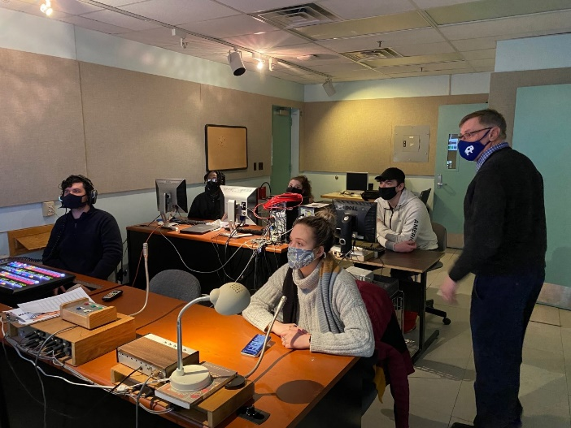
Professor Karnath and COM 429 students in control room

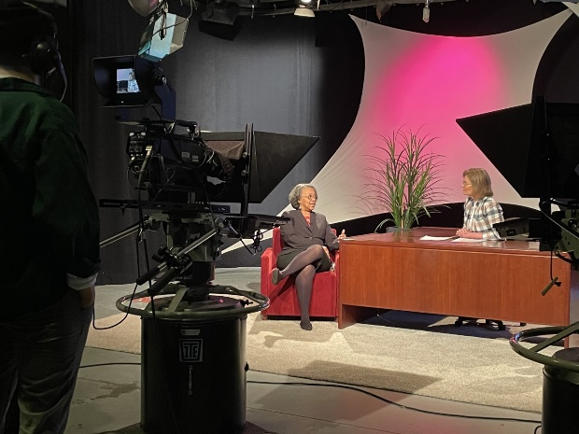
College President Conway-Turner being interviewed by BBA member Erica Brasen


BBA Vice President Steve Monaco, Professor Notarius and Professor Karnath with Reciprocal Partnership Award

- Approval for Media Production Program Revisions – This spring, SUNY and the state Education Department gave final approval to revisions in our Media Production program. The revision adds a hands-on media production course at the 200 level (COM 212 Intro to Digital Storytelling) to engage students in the program at an earlier stage. The revision also specifies a focused critical thinking course, chosen from among four courses, refocuses the intermediate production courses, and adds a second post-production choice to the Advanced Production Course group. Thanks to Media Production professors Meg Knowles, Ruth Goldman, and Dorothea Braemer for their hard work on the revisions!

- Sports Communication Certificate Updates – SUNY and the state Education Department also gave final approval to revisions to our 15-credit Sports Communication Certificate. The certificate gives students enhanced credentials for careers involving sports-related journalism, public relations, and media production. Our revisions added six courses to the major courses with options for sports-related content.

- Hall of Fame Recipient – Congratulations to Bob Williams ’79, who was selected by the Communication Department for our Hall of Fame Award! The award is given biennially to alumni who have achieved an outstanding level of acclaim and influence in communication at the national level. Mr. Williams is senior vice president for communications for the National Collegiate Athletic Association, where he serves as primary media spokesperson and oversees external affairs and strategic communications. He also has spoken to Buffalo State students on several campus visits as well as via Zoom in April. He’ll be on campus to receive his award on Nov. 12.

Bob Williams ‘79

- Academy Award Winner to Visit Campus – Distinguished Buffalo State graduate Deborah Oppenheimer, a prominent film and television producer, will visit Buffalo State on Oct. 20-21, giving an interactive campus-wide master class on “Producing Documentary Film” to students on Oct. 20 followed by a screening of her documentary film “Foster” at 7 p.m. Oct. 21 at the Burchfield Penney Art Center. A recipient of a SUNY Honorary Doctor of Fine Arts degree and a member of our Hall of Fame, Ms. Oppenheimer won an Academy Award in 2001 for Best Documentary Feature for producing “Into the Arms of Strangers: Stories of the Kindertransport.”

Deborah Oppenheimer
- Outstanding Senior Awards – Kudos to our 2021 Outstanding Seniors, Dean’s Award recipient, Piquette Scholarship winner and Adair Award recipient, who were honored at our virtual Senior Sendoff via Zoom on May 14! They include Samantha Pangborn (Media Production), recipient of the department’s top award, the Dean’s Award for Excellence in Communication; Katelyn T. Kardaman and Ryan M. Kirkpatrick, Outstanding Senior in Communication Studies; Liberty S. Darr, Outstanding Senior in Journalism; Alexis Graham and Ayanna Anderson, Outstanding Senior in Media Production; and Evan Atkins and Jake A. Broffman, Outstanding Senior in Public Relations and Advertising. We also honored Daniel May (junior, PR/Advertising) as recipient of the Dr. Julia Piquette Scholarship; and Ryan M. Kirkpatrick as winner of the Charles Adair Award. Zack Reese ’16, manager of decision sciences at Starcom US in Chicago, gave the keynote address.


Samantha Pangborn at Buffalo’s WNED-TV, where she did a spring ’21 internship that led to a full-time job offer.

- “Beyond Boundaries” Film Series: “Beyond Boundaries,” a film screening and discussion series at Buffalo State, will launch its 8th season this fall. The free series, which is offered at 7 p.m. on Thursdays at the Burchfield Penney Art Center, is curated by Meg Knowles and Ruth Goldman, associate professors of communication. “Beyond Boundaries” is sponsored by the Communication Department, the Equity and Campus Diversity Office, and the Burchfield Penney Art Center. Details are on the Equity and Campus Diversity Facebook page: https://www.facebook.com/BSC.EquityandDiversity/. Please join us if you’re in the Buffalo area!

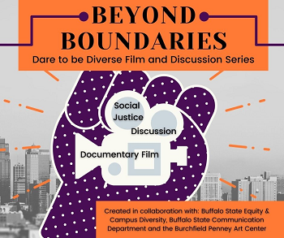

- Ronald D. Smith Memorial Scholarship – The Communication Department is working with the family of the late Professor Ron Smith, longtime Communication Department chair and Public Communication (PR/Advertising) faculty, on creating a scholarship in his memory. The scholarship, to be awarded annually each spring, will be given to a Buffalo State Communication undergraduate student planning a career in public relations, with preference given to students in the B.A. in Public Relations and Advertising degree program. Applicants must have a GPA of 3.5 or higher, demonstrate financial need, and possess excellent writing skills, as evidenced by the submission of an essay of 500 words on the importance of strategic planning in public relations.

You can donate here: https://www.justgiving.com/campaign/buffalostate-ronsmith.


Ron Smith

- Stay in Touch – If you’d like to update us on your career, your company has internships or entry-level job opportunities, or you’d like to speak to a COM class, let us know! Simply reply to this email.
Enjoy the rest of your summer!

Dr. Deborah Silverman, Communication Department Chair

