Email #1 to COM Alumni



Welcome to this first edition of Communication Department News! We’re looking forward to staying in touch with our alumni via periodic emails. (If you wish to unsubscribe, please reply to this email.)

Here’s what’s been happening:

* **A New School** – The college’s School of Arts & Humanities (including COM) is merging this spring with the School of Natural & Social Sciences to form a new School of Arts & Sciences, with Dr. Brian Cronk, newly-appointed Dean of Arts & Sciences, at the helm. The new school will be Buffalo State’s largest; it will create new academic opportunities for students and enhance cross-disciplinary research. Details here: [New Arts and Sciences Dean Brings Extensive Leadership, Innovative Ideas to Role | News | SUNY Buffalo State College](https://suny.buffalostate.edu/news/new-arts-and-sciences-dean-brings-extensive-leadership-innovative-ideas-role)

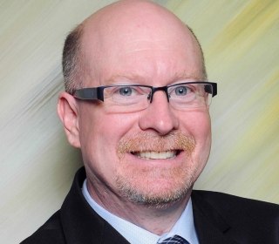

Cronk

* **Teaching during the Pandemic** – COM faculty rose to the challenge of making a quick pivot from largely face-to-face to remote learning last March! Last spring, 59 of our 64 courses were face-to-face; we had two weeks to prepare for online instruction, with help from the college’s Instructional Design & Training staff and our Teaching & Learning Center. Faculty and students participated in many workshops about Blackboard, the web-based learning and course management system used by the college. In fall 2020, about 75 percent of Buffalo State’s courses were online and we expect the same percentage for spring 2021. We’re doing well but we miss seeing our students in person! We expect to resume “normal” instruction (mostly face-to-face courses) for fall 2021.
* **Virtual Fall Research and Creativity Forum** – Like most of our courses, our department’s 2020 Fall Research and Creativity Forum went virtual! The annual event celebrates the scholarly, creative, and professional achievements of our students. Congrats to these students! Check out their work here: [Research & Creativity Forum | Communication | SUNY Buffalo State College](https://communication.buffalostate.edu/fall-forum)
* **Reaccreditation** – Three of our four B.A. degrees (Journalism, PR/Advertising, and Media Production) received reaccreditation in spring 2020 from the Accrediting Council on Education in Journalism and Mass Communications, and our fourth B.A. degree, Communication Studies, successfully underwent a SUNY external review in fall 2020. These rigorous reviews every six years ensure a high-quality educational experience for our students.
* **Alumni Advisory Board** – The department has launched an Alumni Advisory Board, composed of alumni from all five of our degree programs as well as several non-alumni who are media professionals in Buffalo. The board, which meets twice per year, provides input on our curriculum and assistance in assessing our degree programs. Our sincerest thanks to these great volunteers! Details: [Advisory Board | Communication | SUNY Buffalo State College](https://communication.buffalostate.edu/advisory-board)

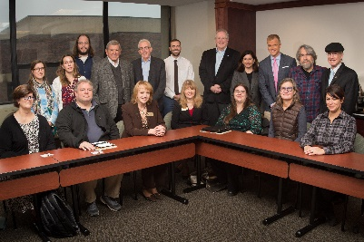

Advisory Board’s first meeting – November 2018

* **Professional Achievement Awards** – Congrats to our 2020 Professional Achievement Award winners: **Therese Fuerst ’03**, M.S. in PR Management, PR/Advertising lecturer in COM and founder/president of Fuerst Consulting Corporation; **David Morales ’12**, B.A. in Media Production, photojournalist with WKBW-TV; and **Mark Hall ’11**, B.A. in Media Production, creative director of commercial production at WGRZ-TV! They were honored Nov. 13 at a virtual presentation ceremony. These awards, presented every other year, honor alumni and other local communication professionals who have achieved a high level of professional success or have made positive contributions to the Communication Department and to the media professions in Western New York.

 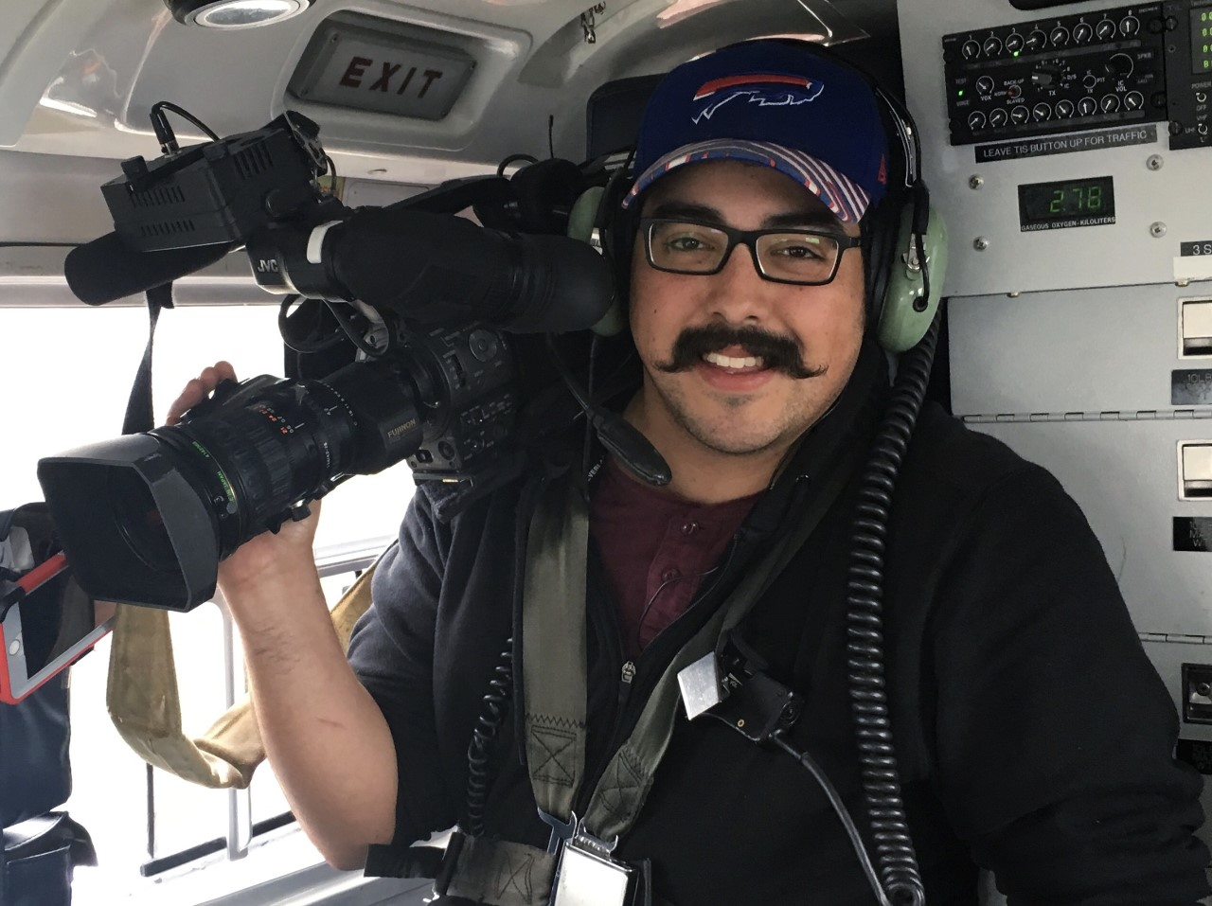

Fuerst Morales Hall

* **Communication Honor Society Induction** – At the same virtual ceremony, we also inducted 19 COM students as new members of Lambda Pi Eta, the National Communication Association’s Honor Society. Congratulations to these outstanding students!
* **Online Master’s Degree** – The department’s online M.S. in Public Relations degree program is up and running, with approximately 20 students enrolled. The 33-credit hour program is designed for working adults enrolled as part-time students and takes about two years to complete.
* **In Memoriam** – We’re sad to announce the deaths of three “champions” for our department, all of whom passed away in September 2020. They include **Dr. Benjamin Christy**, retired Dean of Arts and Humanities; and former Communication Department chairs **W. Richard “Rik” Whitaker** and **Ronald D. Smith**. Dr. Christy was our dean for 12 years – a strong advocate for COM! Professors Whitaker and Smith were long-time faculty members and co-authors, with Professor Janet Ramsey, of our COM 210 textbook, MediaWriting. Our deepest condolences to their families.



Christy Whitaker Smith

* **Keep in Touch** – If your company has internships or entry-level job opportunities, you’d like to speak to a COM class, or you want to update us on your career, let us know! Simply reply to this email.

Best wishes for a brighter and better year in 2021!

Dr. Deborah Silverman, Communication Department Chair